PIZZA SALES SQL QUERIES
-- KPI
-- 1) Total Revenue
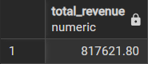
-- 2) Total Orders

-- 3) Total Pizza Sold

-- 4) Average Order Value
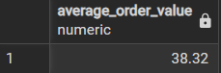

-- 5) Average Pizza Per Order


--Visuals
-- 1) Daily Trend for Total Orders
SELECT
TO_CHAR(order_date, 'DAY') AS order_day,
COUNT(DISTINCT order_id) AS total_order
FROM pizza_sales
GROUP BY order_day
ORDER BY total_order DESC;
Output
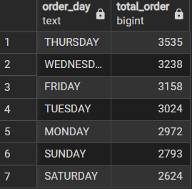

-- 2) Monthly Trend for Orders
SELECT
TO_CHAR(order_date, 'MONTH') AS order_month,
COUNT(DISTINCT order_id) AS total_order
FROM pizza_sales
GROUP BY order_month
ORDER BY total_order DESC;
Output
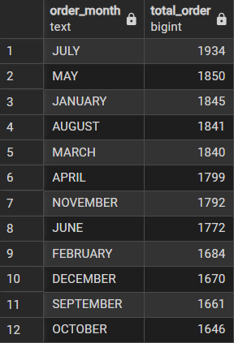

-- 3) % of Sales by Pizza Category
WITH category_sales AS (
SELECT pizza_category,
SUM(total_price) AS total_sales
FROM pizza_sales
GROUP BY pizza_category
)
SELECT pizza_category, total_sales,
CAST(total_sales * 100.0 / (SELECT SUM(total_sales) FROM category_sales)
AS DECIMAL(10,2))
AS sales_percentage
FROM category_sales
ORDER BY sales_percentage DESC;
Output
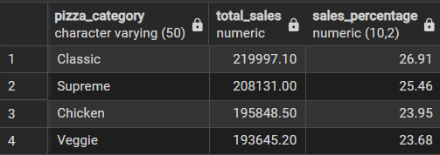
-- 4) % of Sales by Pizza Size
SELECT pizza_size, CAST(SUM(total_price) AS DECIMAL(10,2)) as total_revenue,
CAST(SUM(total_price) * 100 / (SELECT SUM(total_price) from pizza_sales) AS DECIMAL(10,2)) AS PCT
FROM pizza_sales
GROUP BY pizza_size
ORDER BY pizza_size;
Output
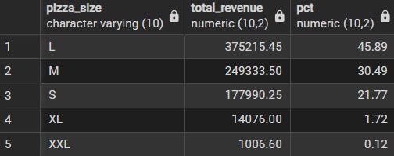
-- 5) Total Pizzas Sold by Pizza Category
SELECT pizza_category, SUM(quantity) AS top_sold
FROM pizza_sales
GROUP BY pizza_category
ORDER BY top_sold DESC;
Output

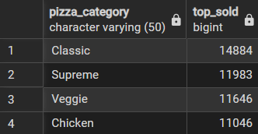
-- 6) Total quantity sold only in January
SELECT pizza_category, SUM(quantity) as Total_Quantity_Sold
FROM pizza_sales
WHERE EXTRACT(MONTH FROM order_date) = 1
GROUP BY pizza_category
ORDER BY Total_Quantity_Sold DESC;
Output
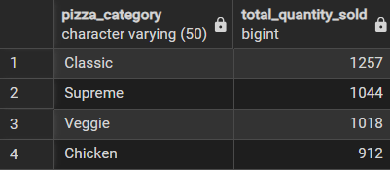
-- 7) Top 5 Pizzas by Revenue
WITH top_pizza AS (
SELECT pizza_name, SUM(total_price) AS total_revenue
FROM pizza_sales
GROUP BY pizza_name
)
SELECT *
FROM top_pizza
ORDER BY total_revenue DESC LIMIT 5;
Output
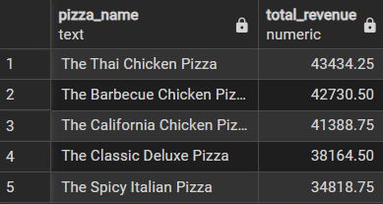
-- 8) Bottom 5 Pizzas by Revenue
SELECT pizza_name, SUM(total_price) AS Total_Revenue
FROM pizza_sales
GROUP BY pizza_name
ORDER BY Total_Revenue ASC
LIMIT 5;
Output
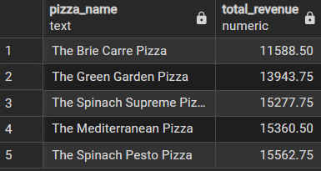
-- 9) Top 5 Pizzas by Quantity
SELECT pizza_name, SUM(quantity) AS Top_quantity
FROM pizza_sales
GROUP BY pizza_name
ORDER BY Top_quantity DESC
LIMIT 5;
Output
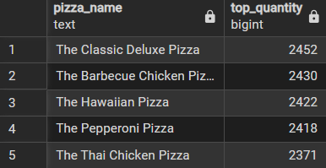
-- 10) Bottom 5 Pizzas by Quantity
SELECT pizza_name, SUM(quantity) AS Bottom_quantity
FROM pizza_sales
GROUP BY pizza_name
ORDER BY Bottom_quantity ASC
LIMIT 5;
Output
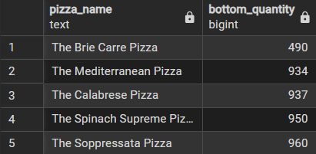
-- 11) Top 5 Pizzas by Total Orders
SELECT pizza_name, COUNT(DISTINCT order_id) AS Top_orders
FROM pizza_sales
GROUP BY pizza_name
ORDER BY Top_orders DESC
LIMIT 5;
Output
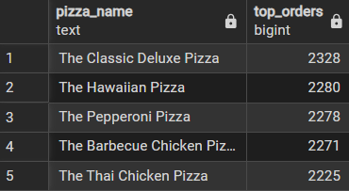
-- 12) Bottom 5 Pizzas by Total Orders
SELECT pizza_name, COUNT(DISTINCT order_id) AS Bottom_orders
FROM pizza_sales
GROUP BY pizza_name
ORDER BY Bottom_orders ASC
LIMIT 5;
Output
-- 13) Finds the 5 Classic pizzas that appeared in the fewest unique orders
SELECT pizza_name, pizza_category, COUNT(DISTINCT order_id) AS total_order
FROM pizza_sales
WHERE pizza_category = 'Classic'
GROUP BY pizza_name, pizza_category
ORDER BY total_order ASC LIMIT 5;
Output
